

SELECT title FROM movies;

SELECT director FROM movies;

SELECT title,director FROM movies;

SELECT title,year FROM movies;

SELECT * FROM movies;

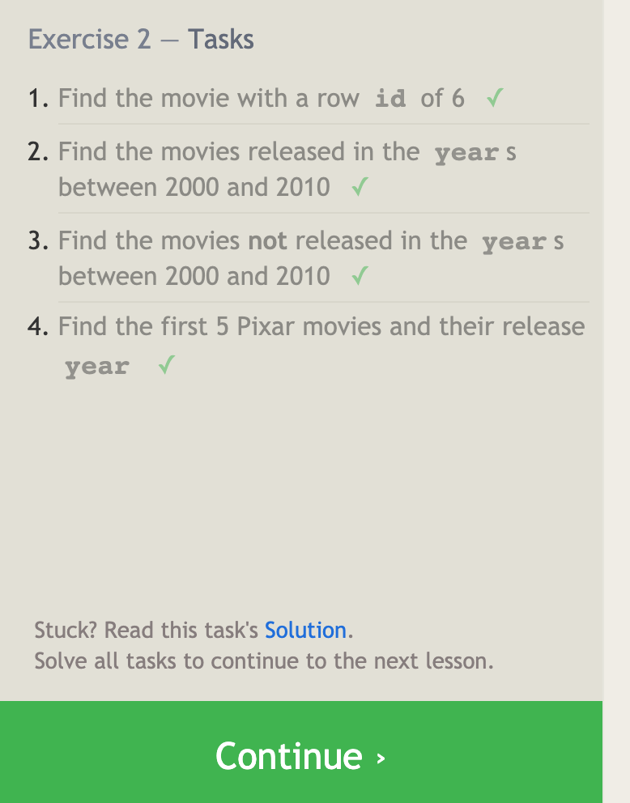

SELECT * FROM movies where id==6;

SELECT * FROM movies where (year >=2000 AND year<=2010) ;

SELECT * FROM movies where (year<2000 OR year>2010) ;

SELECT * FROM movies WHERE year <= 2003;

SELECT * FROM movies where title LIKE "%toy%";

SELECT * FROM movies where director=='John Lasseter';

SELECT * FROM movies where director!='John Lasseter';

SELECT * FROM movies where title LIKE 'WALL-%';

SELECT DISTINCT director FROM movies

order by director asc;

select * from movies order by year desc limit 4;

select * from movies order by title asc limit 5;

select * from movies order by title asc limit 5 offset 5;

SELECT city,population FROM north_american_cities

where country=='Canada';

SELECT * FROM north_american_cities

where country=='United States'

order by latitude desc

SELECT city, longitude FROM north_american_cities

WHERE longitude < -87.629798

ORDER BY longitude ASC;

SELECT city FROM north_american_cities

where country=='Mexico'

order by population desc limit 2

SELECT * FROM north_american_cities

where country=='United States'

order by population desc limit 2 offset 2

SELECT title,Domestic_sales,International_sales

FROM movies

INNER JOIN Boxoffice

ON movies.id == Boxoffice.Movie_id;

SELECT title,Domestic_sales,International_sales

FROM movies

INNER JOIN Boxoffice

ON movies.id == Boxoffice.Movie_id

where International_sales>Domestic_sales;

SELECT title,Domestic_sales,International_sales

FROM movies

INNER JOIN Boxoffice

ON movies.id == Boxoffice.Movie_id

order by Rating desc;

SELECT DISTINCT Building

FROM Buildings

LEFT JOIN Employees

ON Buildings.Building_name == Employees.Building

where Building IS NOT NULL;

SELECT Building_name,capacity

FROM Buildings

SELECT DISTINCT Building_name,ROLE

FROM Buildings

LEFT JOIN Employees

ON Buildings.Building_name == Employees.Building ;

SELECT ROLE,NAME,BUILDING FROM EMPLOYEES

WHERE BUILDING IS NULL

SELECT *

from Buildings

LEFT JOIN Employees

ON Buildings.Building_name == Employees.Building

WHERE Building is NULL;

SELECT title,

(Domestic_sales+International_sales)/1000000 as Total_sales FROM movies

INNER JOIN Boxoffice

ON movies.Id == Boxoffice.Movie_id;

SELECT title,

rating*10 as Ratings FROM movies

INNER JOIN Boxoffice

ON movies.Id == Boxoffice.Movie_id;

SELECT title, year as EVEN_Years FROM movies where year%2 == 0

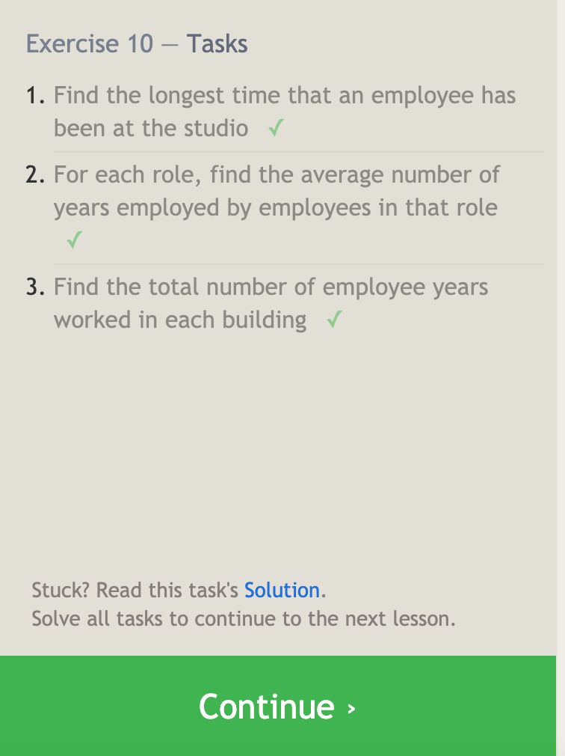

SELECT MAX(Years_employed) FROM employees;

SELECT role, AVG(Years_employed) from Employees

GROUP BY role

SELECT Building, SUM(Years_employed) from Employees

GROUP BY Building



SELECT COUNT() FROM employees

WHERE Role =='Artist';

SELECT Role, COUNT() as Count from Employees

GROUP BY Role

SELECT Role, SUM(Years_employed) as Total_years from Employees

GROUP BY Role

HAVING Role=='Engineer'

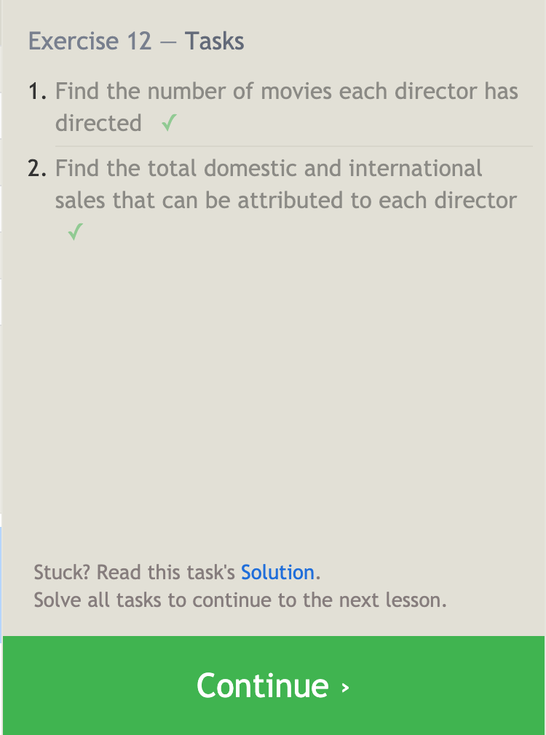

SELECT Director,COUNT() as COUNT FROM movies

GROUP BY Director;

SELECT Director,SUM(Domestic_sales+International_sales) as Total_sales

FROM movies

INNER JOIN Boxoffice

ON movies.id==Boxoffice.Movie_id

GROUP BY Director;

INSERT INTO movies

(Title,Director,Year,Length_minutes)

VALUES('Toy Story 4','John Lasseter',2021, 100);

INSERT INTO Boxoffice

(Movie_id,Rating,Domestic_sales,International_sales)

VALUES((select Id from movies where title=='Toy Story 4'),8.7,340*1000000,279*1000000);

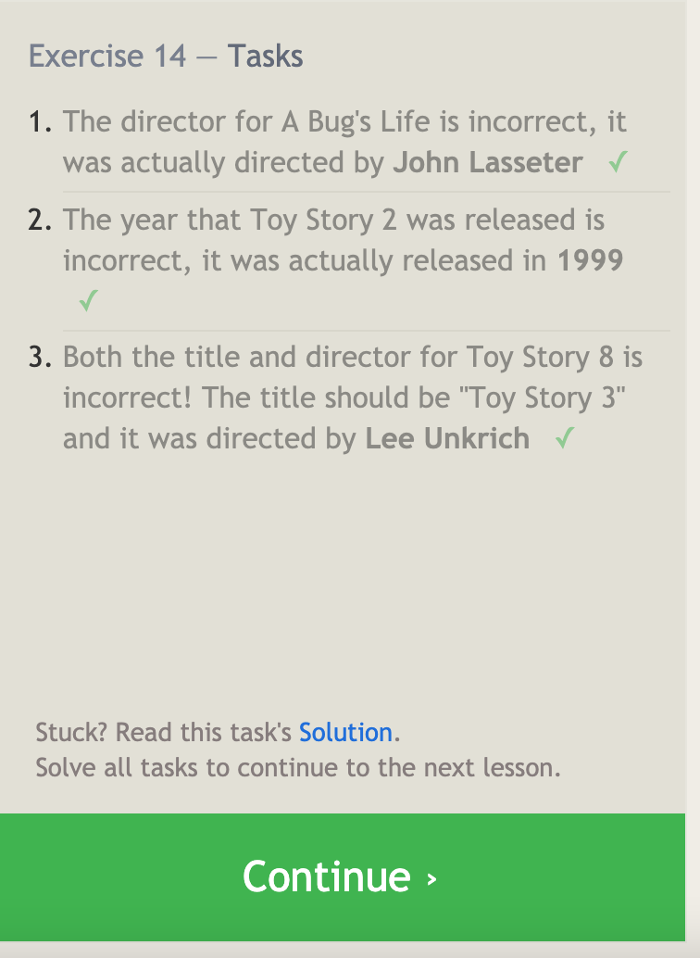

UPDATE Movies

SET Director='John Lasseter'

WHERE Title IS "A Bug's Life"

UPDATE Movies

SET Year='1999'

WHERE Title IS "Toy Story 2"

UPDATE Movies

SET Title='Toy Story 3',

Director='Lee Unkrich'

WHERE Title IS "Toy Story 8"

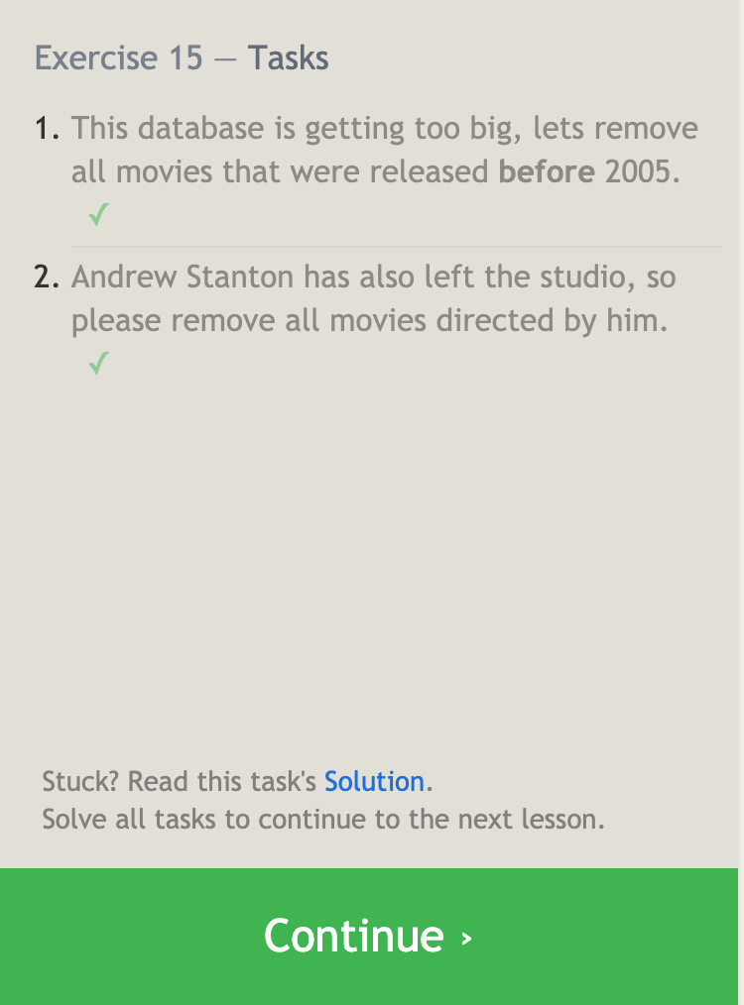

DELETE FROM movies

WHERE Year<2005;

DELETE FROM movies

WHERE Director IS 'Andrew Stanton';

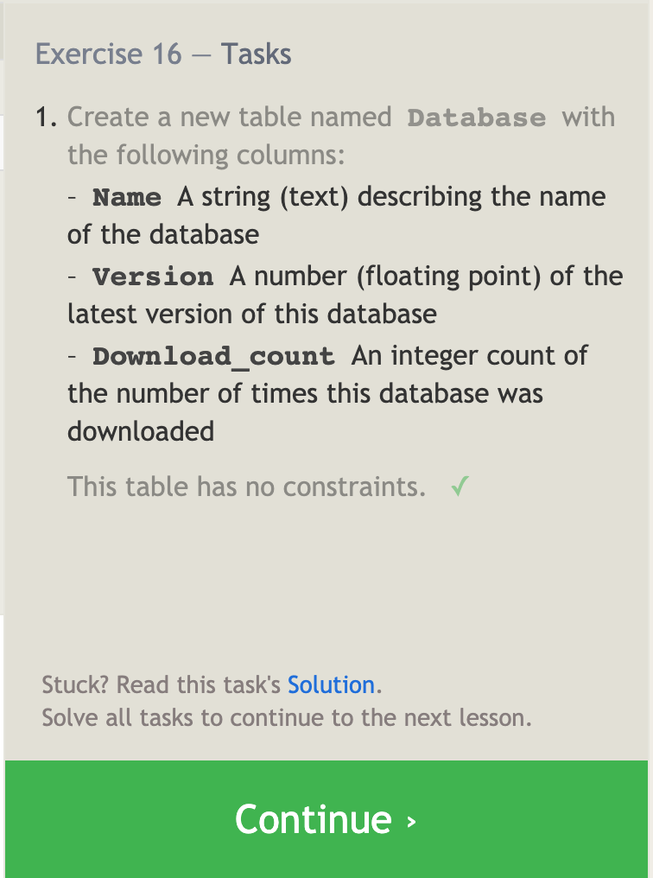

CREATE TABLE IF NOT EXISTS Database(

Name TEXT,

Version FLOAT,

Download_count INTEGER

)

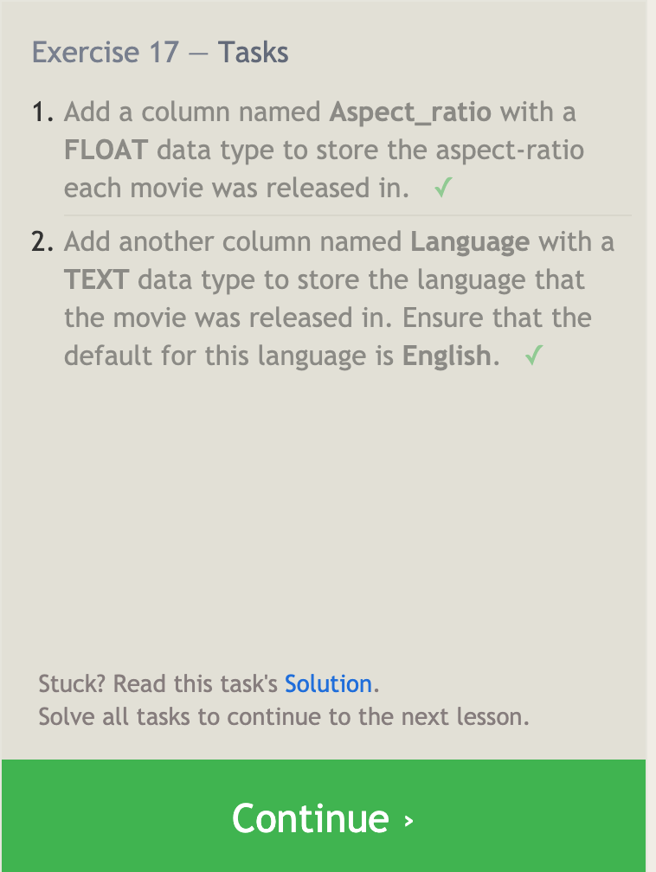

ALTER Table Movies

ADD Aspect_ratio FLOAT;

ALTER Table Movies

ADD Language TEXT DEFAULT 'English';

DROP Table IF EXISTS Movies

DROP Table IF EXISTS Boxoffice